|  |  |
| --- | --- |
|  | **GEORGETOWN DIVIDE PUBLIC UTILITY DISTRICT**  **Policy and Procedures Manual** |

**POLICY TITLE: Low-Income Rate Assistance Program**



**POLICY NUMBER: 2180 Adopted: March 13, 2018 Amended: March 7, 2024 and June 11, 2025**

**REFERENCES:**

**Section 2180.01 Purpose**

The Board of Directors of the Georgetown Divide Public Utility District (District) desires to offer financial assistance to low-income residential treated water customers.

# Section 2180.02 Eligibility

1. Must receive treated water service from the District.
2. Customer must live (primary residence) at the address receiving the discount.
3. Must be a residential customer.
4. Meet the income guidelines outlined in Section 3.
5. Customer must notify the District when no longer eligible.
6. Customer must submit for renewal by June 30 each year.
7. Qualification is based on the total income of everyone living in the home or participation in qualifying public assistance programs.

# Section 2180.03 Income Verification

* 1. Qualification is based on the total household gross income as specified in Section 2180.04.
  2. Two methods of demonstrating:
     1. Provide a copy of PG&E bill showing California Alternate Rates for Energy (CARE) program enrollment for treated water account holder; or
     2. Submit income documentation to the District for review and approval.
        1. Customer must account for all sources of qualifying household income.
        2. Current enrollment in certain public assistance programs. .
        3. Customers must black out any account numbers or Social Security numbers.

1) Customers must provide income information for all members of the household. This information may include several of the documents listed below:

GDPUD Policy 2180 – Low Income Rate Assistance Page 1 of 4

|  |  |
| --- | --- |
| If you or someone in your household participates in | You should send in a copy of: |
| Public Assistance Programs | Award letter(s) OR letter of participation in the program(s) |
| Medicaid/Medi-CAL, Supplemental Security Income (SSI), CalFresh/SNAP (Food Stamps), LIHEAP, WIC, Healthy Families A & B, Cal WORKs (TANF), National School Lunch Program (NSLP), Bureau of Indian Affairs General Assistance, Head Start Income Eligible  (Tribal Only) |

|  |  |
| --- | --- |
| If you or someone in your household receives income from: | You should send in a copy of: |
| Wages, Salaries, Tips, Commissions | Two most recent consecutive check stubs, W2 or IRS 1040 Form |
| Pensions, Social Security, SSP, SSDI, Disability Payments, Workers Compensation, Unemployment Benefits, VA Benefits, Foster Care Payments | Award letter(s), two most recent consecutive check stubs, or the most recent bank statement (to show direct deposit) |
| School Grants, Scholarships, Other Aid | Award Letter(s) OR two most recent consecutive check stubs |
| Insurance and/or Legal Settlements | Settlement Documents |
| Child and/or Spousal Support | Court documents OR two most recent consecutive check stubs |
| Farm Income | First page of IRS 1040 |
| Interest and/or Dividends from Savings, Stocks, Bonds, Mutual Funds | IRS Form 1040 or IRS Form 1099(s) or three consecutive bank statements |
| 401K or IRA withdrawals or Annuities | Investment account statement(s), IRS Form 1040 or IRS Form 1099 |
| Capital Gains | Investment account statement(s), IRS Form 1040 or IRS Form 1099 |
| Rental and/or Royalty Income | IRS Form 1040 AND Schedule E for Rental Income |
| Profit from Self-Employment | IRS Form 1040 and Schedule C |
| Gambling/Lottery Winnings | Determined on a case-by-case basis |
| Union Strike Fund Benefits | Two most recent consecutive benefit check stubs |
| Cash Income (when you have not filed federal or state taxes) | Signed letter detailing type of work, estimated monthly amount of cash payment, employer name and phone  number |
| Monetary gifts, none of the examples apply or if you do not receive any income | Signed letter explaining the current source(s) of income used to support your household. |

GDPUD Policy 2180 – Low Income Rate Assistance Program Page 2 of 4

# Section 2180.04 Gross Income Limits

1. The District will use the most current income limit information from the CA Department of Housing and Community Development Official State Income Limits for El Dorado County (updated in December each year) for the extremely low (15-30% of AMI) and very low (30% to 50% of AMI) categories.

# Section 2180.05 Discount Amount

1. Customers will receive a discount of 50% off the base rate of treated water.
2. This will be reviewed by staff annually on or before June 30, to determine suitability. Any changes require approval by the Board of Directors.

# Section 21803.06 Eligibility Renewal

1. Renewal information must be received by the District before June 30th annually.
2. Participants will be notified by mail in the April and May bills to resubmit their eligibility information.

# Section 21803.07 Fund Limit $50,000 and Wait List

1. The maximum property tax revenue that will be allocated to this program (fund limit

$50,000) will be determined as part of the annual budget process. Rate revenues shall not be used to fund the discount.

1. A change to the fund limit can be authorized by action of the Board of Directors.
2. Staff will provide information on projected discount expenses during the annual budget process to the Board of Directors
3. Discounts for the fiscal year will be applied on a first-come, first-served basis for both new applicants and renewal applicants.
4. If customer demand exceeds the fund limit, a waitlist will be created.
5. Customers on the wait list will be enrolled into the program on a first-come, first- served basis as funds become available.
   1. If a customer has been on the waitlist for more than 6 months, the customer must re-submit income eligibility information in order for the application to be reviewed before enrollment in the program.

# Section 21803.09 Program Acceptance

1. Customers may apply at any time for initial applications and by June 1 for renewals; however, they may be placed on a waitlist based on funding availability.
2. The District may require up to 30 days to provide a determination of a customer’s eligibility for a discount.
3. Discounts will be distributed as listed in Section 2180.03.
4. For customers described in Section 2180.03 (b), additional time may be required for written agreements before a discount can be applied.
5. Applicants will be sent verification of the District’s receipt of the application via email or WaterSmart notification.

GDPUD Policy 2180 – Low Income Rate Assistance Program Page 3 of 4

# Section 21803.10 Marketing and Outreach

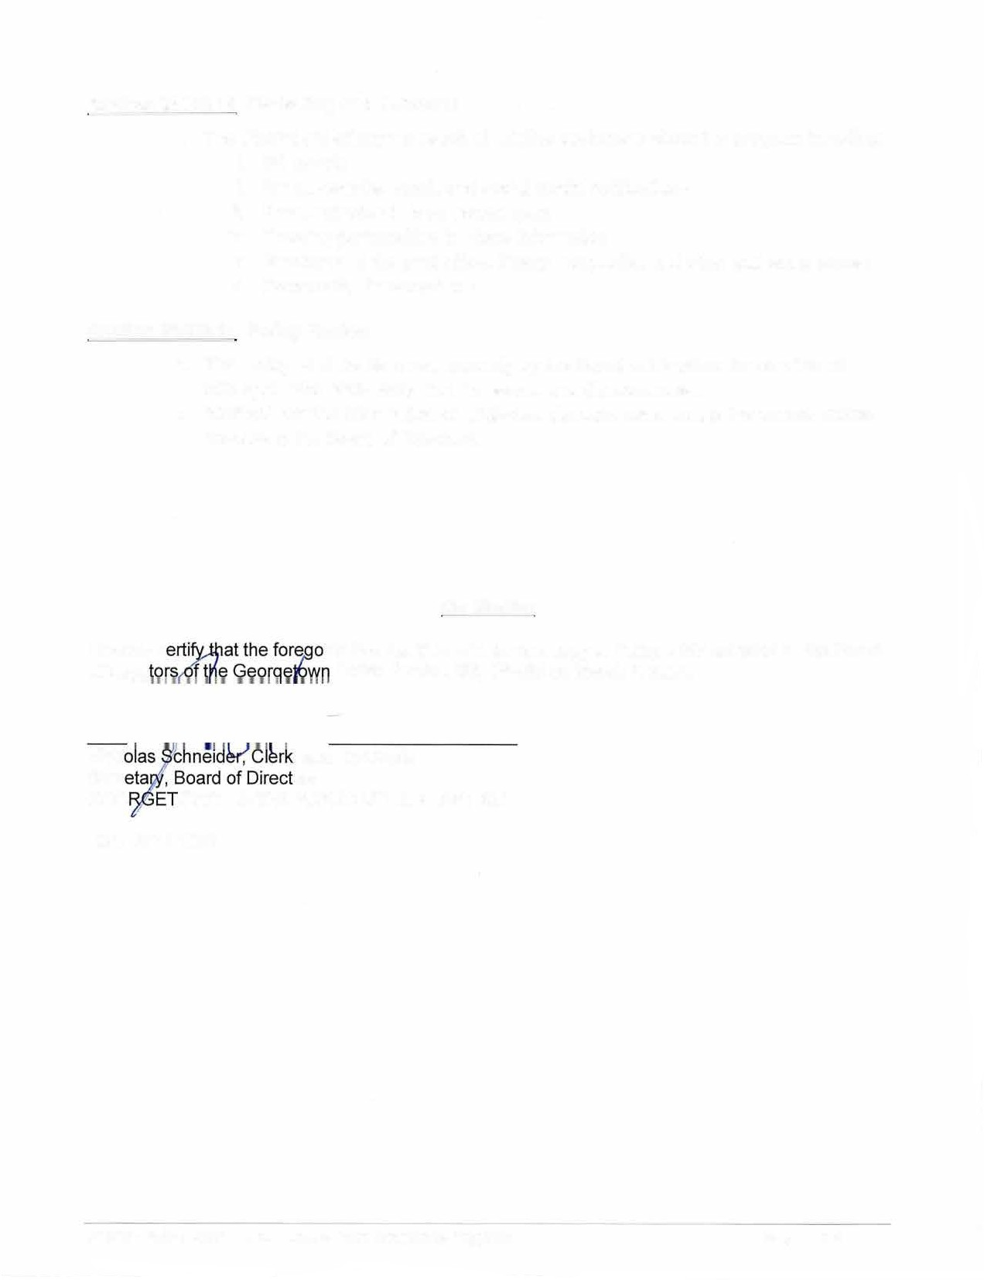

1. The District will attempt to reach all eligible customers about the program including:
   1. Bill Inserts
   2. Email, website, email, and social media notifications
   3. Press releases to local newspapers
   4. Creating partnerships to share information
   5. Brochures at the post office, library, nonprofits, and other gathering places
   6. Community Presentations

# Section 21803.11 Policy Review

1. This policy shall be reviewed annually by the Board of Directors for consistency with applicable state laws, income levels, and discount rates.
2. Staff will provide information on projected discount costs during the annual budget process to the Board of Directors.

Certification

I hereby c ing is a full, true, and correct copy of Policy 2195 adopted by the Board of Direc Divide Public Utility District on March 7, 2024.

Nich , and Ex-Officio

Seer ors

GEO OWN DIVIDE PUBLIC UTILITY DISTRICT DISTRIBUTION:

GDPUD Policy 2180 - Low Income Rate Assistance Program Page 4 of 4